

MADE BY:-

ASMIT

KUSHAGRA

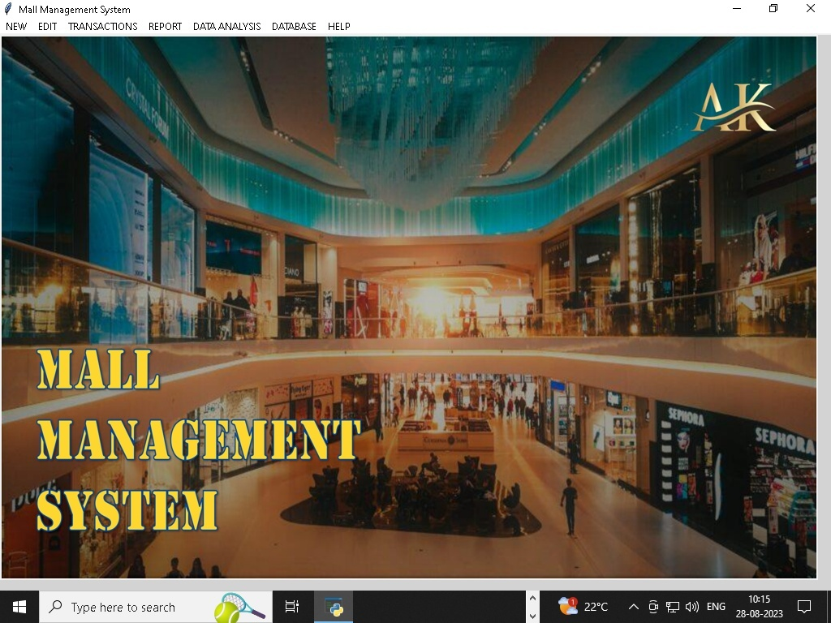

# ACKNOWLEDGEMENT

I take this opportunity to express my deep sense of gratitude to all those who have been instrumental in preparation of this project.

I feel great pleasure to express my obligation to **Mr. Anil Kumar Sharma, Principal of Birla Vidya Mandir, Nainitial.**

I am also sincerely grateful to **Mr. Kirti Kamal Bharadwaj, Birla Vidya Mandir** for his encouragement and valuable guidance during the entire period of work.

I would also thank all of my friends for their whole hearted support and encouragement without with this project would not have been successful.

I could not forget Internet, Textbooks which provided me with sufficient matter for reference.

# DECLARATION

I **Asmit and Kushagra**, bearing folio number 2205502 and 2185314, students of Class XII **Birla Vidyamandir** hereby declare that we own the full responsibility for the information, results etc. provided in this PROJECT titled “**Mall Management System**”. It has been developed successfully by using the Data Handling concepts like data management, data visualization etc. provided in the programming language Python at **Birla Vidyamandir** in complete fulfillment of project (curriculum of Central Board of Secondary Education CBSE of Informatics Practices (065) conducted by CBSE, New Delhi for the academic session 2023-24. I also declare that this project work has neither been submitted to any other board nor published at any time by us in the past.

Asmit Gupta

2205502

12A

Birla Vidyamandir

Kushagra Awasthi

2185314

12A

Birla Vidyamandir

# Certificate

**This is to certify that the Informatics Practices project on Mall Management System has been successfully completed by Asmit Gupta and Kushagra Awathi of Class XII, Birla Vidyamandir for consideration in partial fulfillment of curriculum of Central Board of Secondary Education (CBSE) of Informatics Practices (065) for the award of AISSCE Practical Examination 2023-24.**

**I certify that this project is up to my expectation and as per the guidelines issued by the CBSE.**

External Examiner

Internal Examiner

# INDEX

ACKNOWLEDGEMENT 2

DECLARATION 3

Certificate 4

INDEX 5

INTRODUCTION 5

TECHNOLOGY USED 7

PROBLEM STATEMENT 8

OBJECTIVE 9

PROJECT MODULES 10

USER INTERFACE 12

FUCTIONALITY 13

DATA FLOW DIAGRAM 14

OVERVIEW OF PYTHON 15

OVERVIEW OF MYSQL 16

TABLE STRUCTURE 17

PROJECT SCOPE 21

FUTURE IMPROVEMENTS 22

CONCLUSION 23

BIBLIOGRAPHY 24

SCREENSHOTS 25

# INTRODUCTION

**Shopping Mall a very large building or buildings containing a lot of stores and restaurants, usually with space outside for parking.**

**Mall management is defined as an overall operation and maintenance of the entire building infrastructure, including the services and utilities, ensuring that they are used in a way that are consistent with the purpose for which it was acquired.**

**Mall management has been identified as a critical factor for the success of malls and the retail industry across the world. From managing operations, facilities, security, accounts, marketing & promotion, leasing and all the other functions are the important facets to run a mall successfully.**

# TECHNOLOGY USED

The project utilizes the following technologies:

* **Programming Language**:

Python (Programming Language for Application Logic)

* Database Management System:

MySQL (Backend RDBMS)

* User Interface:

Tkinter (Frontend Python library for GUI)

* Version Control:

Windows 10 Folders

* Testing Framework:

Python 3.7.3 IDLE and MySQL 5.7 on Windows 10

* Deployment:

Windows 10 Folders after installing XAMPP 3.2.2 (for MySQL 5.7 with Server. Type MariaDB 10.1.21 and Database Client Version: mysqlnd 5.0.11) and Python 3.7.3 withIDLE (Integrated Development and Learning Environment).

# PROBLEM STATEMENT

**For efficient Mall Management, a good computerized system solves the following problems:-**

* **Security of data, documents related to business transactions**
* **Unable to keep single copy of data at single location which increases data complexity**
* **Managing data consistency**
* **Accessing and referencing or search data quickly**
* **Unable to analyze data as there is no mechanism to visualize data**

# OBJECTIVE

The objective of project is to build an application program to:

* Provide function to manage stores in the shopping mall more efficiently.
* Provide searching facility based on various factors.
* Reduce time and cost to control and manage mall.
* Reduce paperwork.
* Increased accuracy and reliability.
* Increased Data Consistency.
* Increased Data security.

This application program can be used easily by non-programming personals too.

# PROJECT MODULES

Mall Management System is divided into following modules:

**Database Connection Module:**

To establish a connection between database(MYSQL) and program(PYTHON) using library ‘pymysql’

**Menu Module:**

This module helps us to create a user friendly interface.

It consist of menu function that provide us with pop-ups from which we can select the tables on which we have to perform the task.

The major role of this module is that it helps in designing the structure of expense and income interface.

**Analyzing &Plotting Module:**

This module is used to analyze the desired condition and plot a graph (bar, line, histograms) on the same. To construct a graph in python we need a special library known as MATPLOTLIB. In this module we only need a PYPLOT from this library.

This module includes various functions like:

1. Comparison function which helps us to compare different data sets with desired value.
2. Structure function which contains the gui code for the interface of this module.
3. Create function that helps to build the required chart as per the need of the user.
4. Analyzing function which helps us to analyze the condition by graphs and table structure.

**Database Module:**

This module is used to manage databases required to manage this mall.

One can create, restore and backup databases from this module as it contains functions for the same.

All the table structures are planned here only as it includes a function for table creation with test values. This function contains multiple SQL queries which help us to outline the table structures.

**About Module:**

This module provides us with a special field that helps us to know the software better. It include three functions-

1. Help 🡪For any information, solution to query and problem
2. About 🡪 It provides a broad outline of the software.
3. Manual 🡪it defines the work flow the software.

# USER INTERFACE

The user interface is developed using the Tkinter library. It provides an intuitive and user-friendly experience, with features such as:

* Login and authentication screens.
* Mall management screens for adding, updating, and deleting items.
* Search functionality to find specific items.
* A dashboard with statistics and reports.

# FUCTIONALITY

The system offers the following functionalities:

* **User registration and login.**
* **Role-based access control.**
* **Adding new inventory items.**
* **Updating existing items.**
* **Deleting items.**
* **Searching for items based on various criteria.**
* **Generating reports.**
* **Generating charts, plots and statistics.**
* **Logging user actions and system events.**
* **Help, Guide, Manual and About sections.**

# DATA FLOW DIAGRAM

MENU

MYSQL

EXPENSE

INCOME

EMPLOYEE

SHOWROOM

SERVICE

ADD

UPDATE

DELETE

# OVERVIEW OF PYTHON

Python is a general purpose, dynamic, high-level, and interpreted programming language. It supports Object Oriented programming approach to develop applications.

Features of Python:

* Python is a high level language. It is a free and open source language.
* It is an interpreted language, as Python programs are executed by an interpreter.
* Python programs are easy to understand as they have a clearly defined syntax and relatively simple structure.
* Python is case-sensitive. For example, NUMBER and number are not same in Python.
* Python is portable and platform independent, means it can run on various operating systems and hardware platforms.
* Python has a rich library of predefined function.

# OVERVIEW OF MYSQL

MySQL is a relational database management system (RDBMS). MySQL was originally founded and developed in Sweden by David Axmark, Allan Larsson and Michael Widenius, who had worked together since the 1980s.

Characteristics of MySQL:

* MySQL is released under an open-source license so it is customizable.
* It requires no cost or payment for its usage.
* MySQL has superior speed, is easy to use and is reliable.
* MySQL uses a standard form of the well-known ANSI-SQL standards.
* MySQL is a platform independent application which works on many operating systems like Windows, UNIX, and LINUX etc. and has compatibility with many languages including JAVA, C++, PHP, PERL, etc.
* MySQL is an easy to install RDBMS and is capable of handling large data sets.

# TABLE STRUCTURE

**showroom**

|  |  |  |  |
| --- | --- | --- | --- |
| Field | Type | Null | Key |
| showroomcode | VARCHAR(30) | No | PRI |
| showroomname | VARCHAR(30) |  |  |
| rentpermnth | DECIMAL(8,2) |  |  |
| showroomcategory | VARCHAR(30) |  |  |
| floornum | int(10) |  |  |
| rentgstrate | DECIMAL(5,2) |  |  |

**showroomcategory**

|  |  |  |  |
| --- | --- | --- | --- |
| Field | Type | Null | Key |
| showroomcategory | VARCHAR(30) |  | PRI |

**employee**

|  |  |  |  |
| --- | --- | --- | --- |
| Field | Type | Null | Key |
| emp_id | INT |  | PRI |
| emp_name | VARCHAR(30) |  |  |
| emp_mobile | VARCHAR(10) |  |  |
| emp_category) | VARCHAR(30 |  |  |

**employeecategory**

|  |  |  |  |
| --- | --- | --- | --- |
| Field | Type | Null | Key |
| employeecategory | VARCHAR(30) |  | PRI |

**expense**

|  |  |  |  |
| --- | --- | --- | --- |
| Field | Type | Null | Key |
| expensecode | VARCHAR(30) |  | PRI |
| expensename | VARCHAR(30) |  |  |
| expensecost | DECIMAL(10,2) |  |  |
| expensecategory | VARCHAR(30) |  |  |
| expensegstrate | DECIMAL(5,2) |  |  |

**expensecategory**

|  |  |  |  |
| --- | --- | --- | --- |
| Field | Type | Null | Key |
| expnesecategory | VARCHAR(30) |  | PRI |

**servicecategory**

|  |  |  |  |
| --- | --- | --- | --- |
| Field | Type | Null | Key |
| servicecategory | VARCHAR(30) |  | PRI |

**service**

|  |  |  |  |
| --- | --- | --- | --- |
| Field | Type | Null | Key |
| sevicecode | INT(11) |  | PRI |
| servicename | VARCHAR(30) |  |  |
| servicecostgst | DECIMAL(8,2) |  |  |
| servicecost | VARCHAR(30) |  |  |

**income**

|  |  |  |  |
| --- | --- | --- | --- |
| Field | Type | Null | Key |
| sdate | DATE |  |  |
| incomecd | VARCHAR(30) | No | PRI |
| showroomcode | VARCHAR(30) |  |  |
| showroomname | VARCHAR(30) |  |  |
| showroomcategory | VARCHAR(30) |  |  |
| rentgstrate | DECIMAL(5,2) |  |  |
| rent | DECIMAL(10,2) |  |  |
| month | INT(11) |  |  |
| amount | DECIMAL(10,2) |  |  |
| gst | DECIMAL(10,2) |  |  |
| netamount | DECIMAL(10,2) |  |  |

**transexpense**

|  |  |  |  |
| --- | --- | --- | --- |
| Field | Type | Null | Key |
| pdate | DATE |  |  |
| invoice | VARCHAR(11) | No | PRI |
| expensecode | INT(11) |  |  |
| expensename | VARCHAR(30) |  |  |
| expensecategory | VARCHAR(30) |  |  |
| expensegstrate | DECIMAL(5,2) |  |  |
| cost | DECIMAL(10,2) |  |  |
| gst | DECIMAL(10,2) |  |  |
| netamount | DECIMAL(10,2) |  |  |

# PROJECT SCOPE

Managing all SHOWROOMS, SUFFICIENT EMPLOYEES, SALE and EXPENSE records and analyzing the same is a tedious job for any business. To do it more effectively and correctly a good MALL MANAGEMENT is required. This is provided by our application which have following scope:

* Ensures effective control
* Manage daily sales records easily and precisely
* Can perform sales analysis of various tasks
* User friendly interface
* High level security of data.

# FUTURE IMPROVEMENTS

Future improvements for the Mall Management System (wrt application logic) include:

* **Enhancing the user interface for a more modern and intuitive design.**
* **Adding barcode scanning functionality for quicker data entry.**
* **Integrating with external systems such as e-commerce platforms.**
* **Implementing alerts and notifications for error in Mall. .**
* **Providing mobile access through a dedicated app.**

Future improvements for the Mall Management System (wrt software development &amp; deployment) include:

* **Version Control: Git**
* **Testing Framework: PyTest**
* **Deployment Platform: Local server, Web Server, Cloud**

# CONCLUSION

This Mall Management System is a simple desktop based application basically suitable for small organization. It has all basic elements which are used for managing mall.

We are successful in making the application where we can insert, delete, update, search and analyze records as per need. This application also provides a report including chart of sales records to analyze the performance.

We strongly believe that the implementation of this system will surely benefit the organization.

# BIBLIOGRAPHY

* **Informatics Practices Class-XII NCERT Publication.**
* [**www.ncert.co.in**](http://www.ncert.co.in)
* [**Sample project (BY- Mr. Kirti Kamal Bharadwaj)**](../Mall%20Management%20System)
* **Libraries involved:**

**Tkinter**

**Pillow**

**PyMysql**

**Numpy**

**Matplotlib**

**Fpdf**

# SCREENSHOTS

ROOT WINDOW (HOMEPAGE)

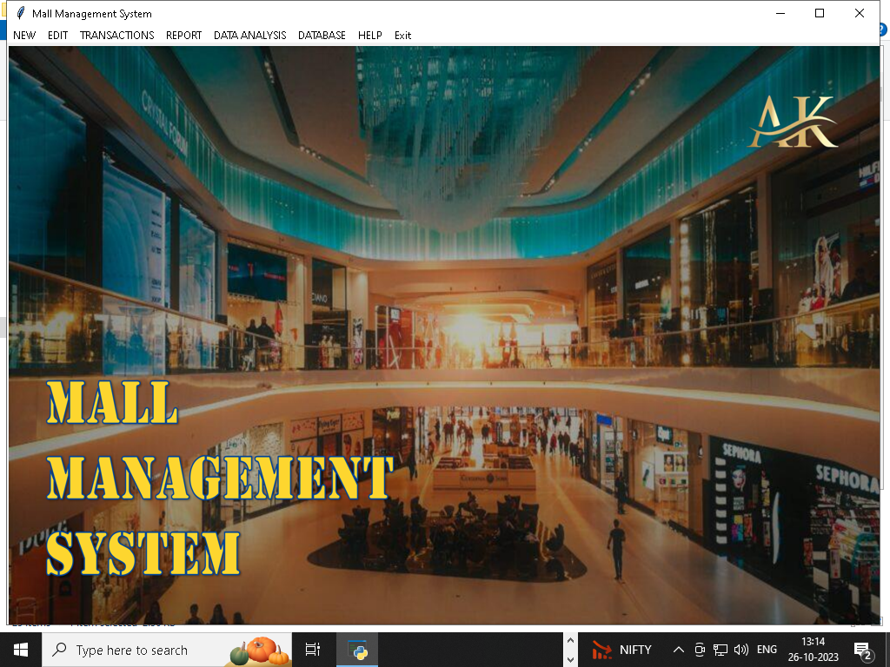

INSERT ROOTFRAME (INSERT TAB)

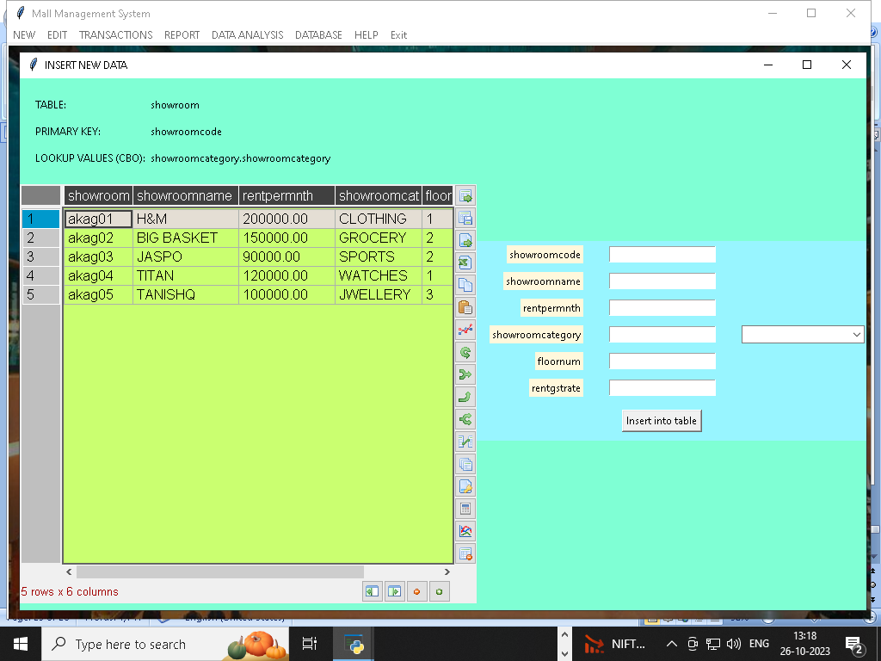

REPORT ROOTFRAME (Data Analysis)

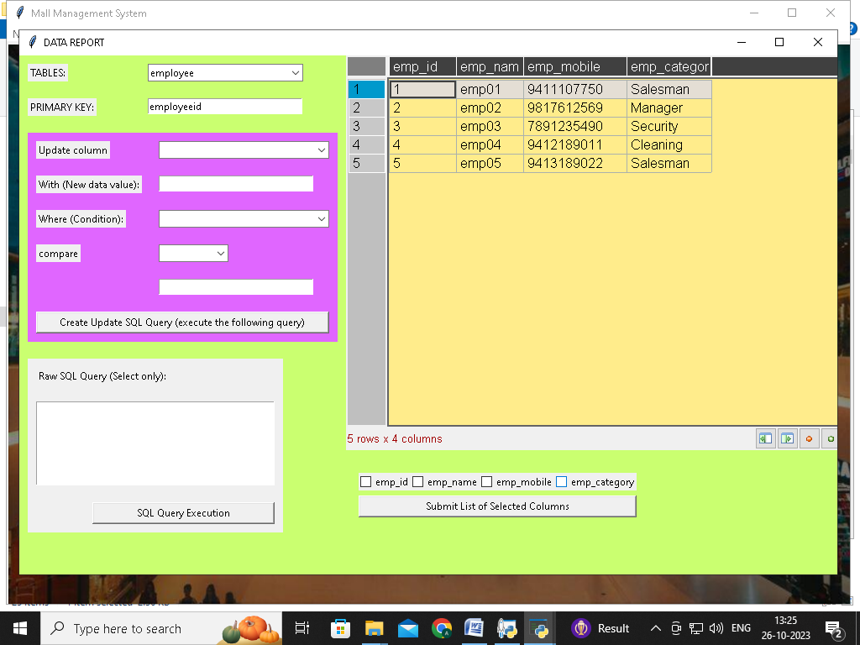

TRANSACTION ROOTFRAME (RECORD ENTRY)

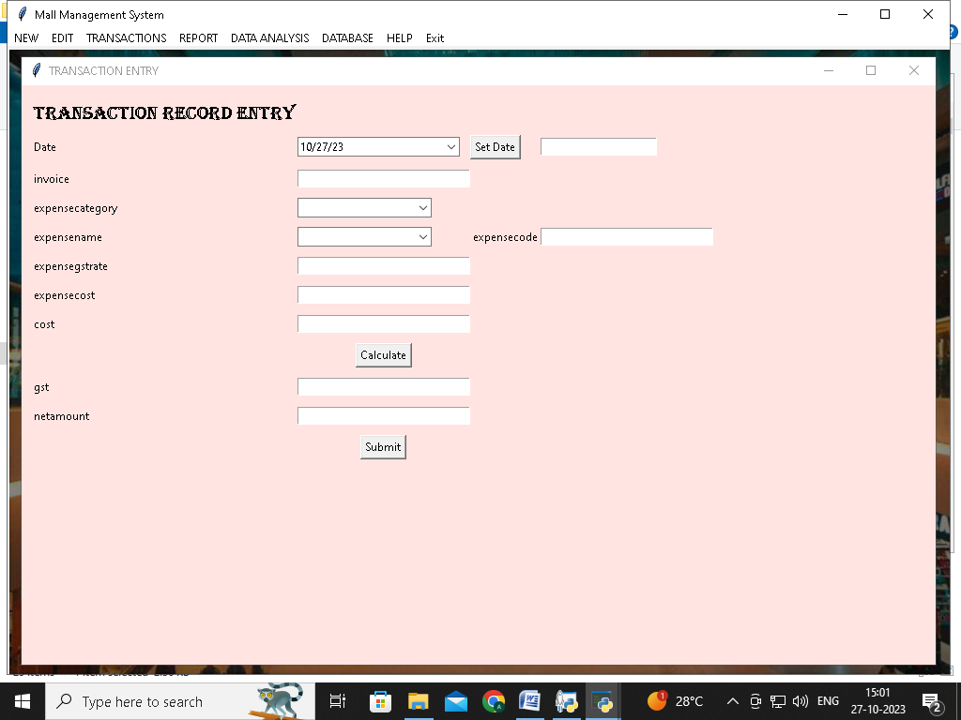

DATA ANALYSIS (COMPLETE)

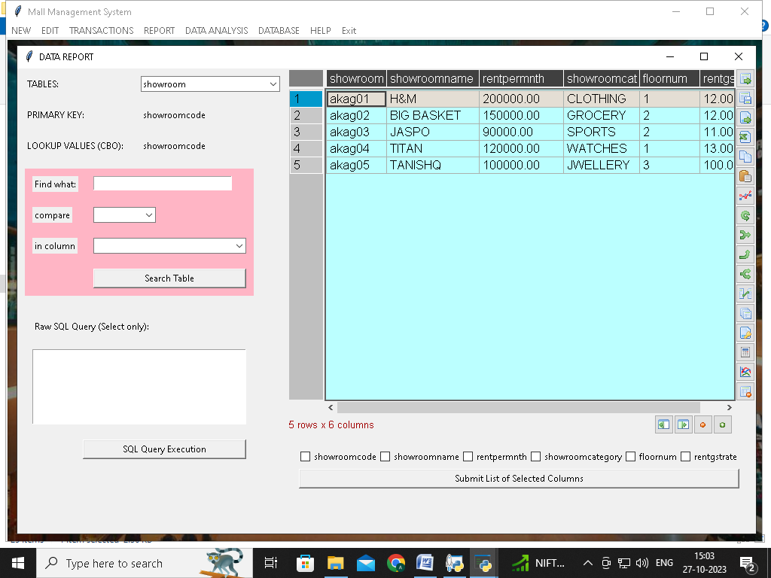

DATA ANALYSIS(CUSTOM)

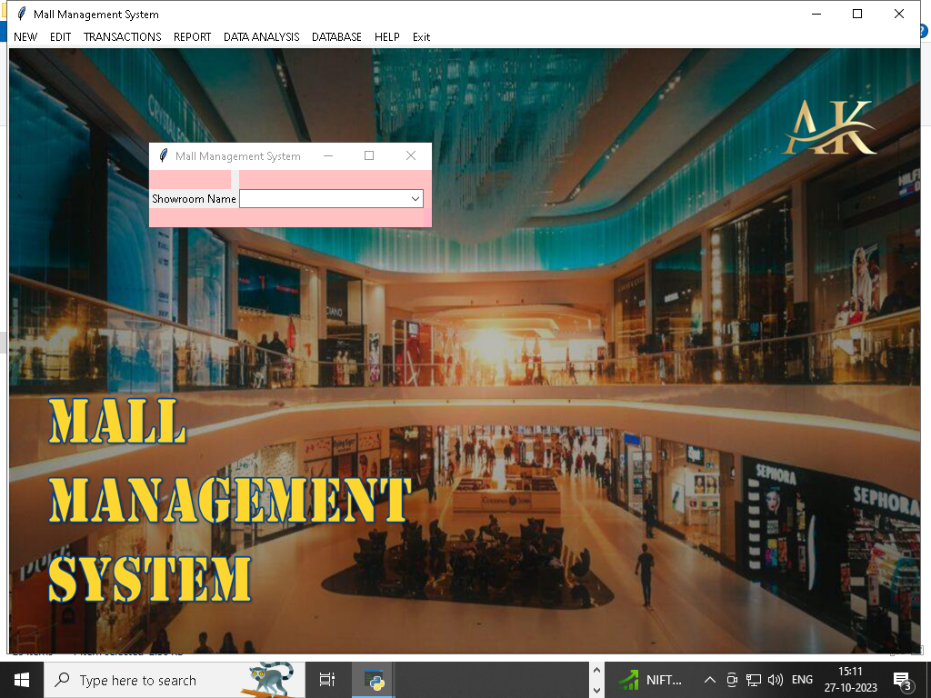

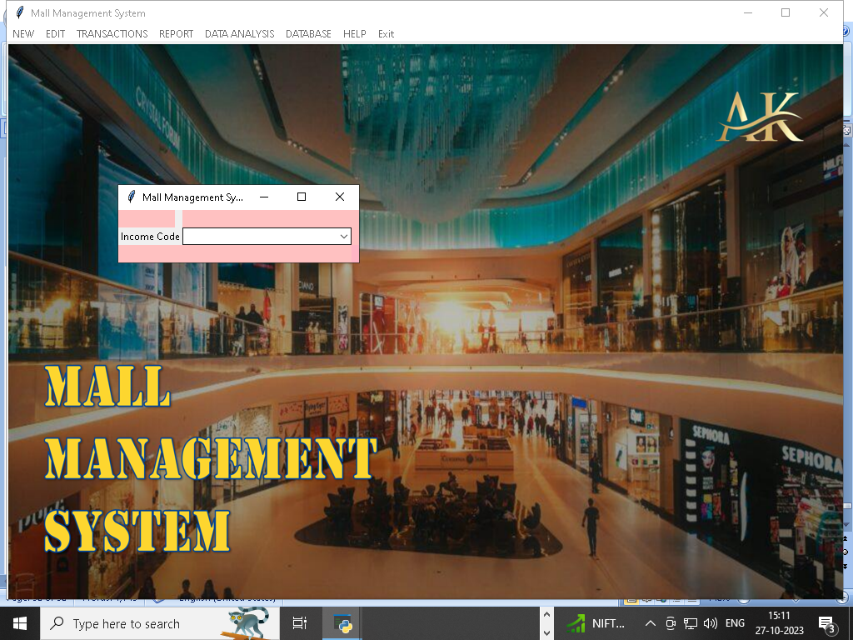

GRAPH DATA (ENTRY PAGE)

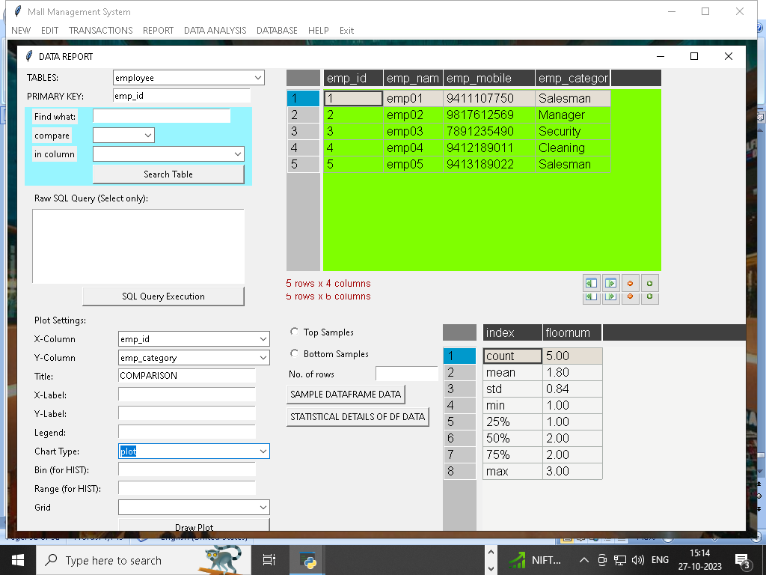

CUSTOM DATA

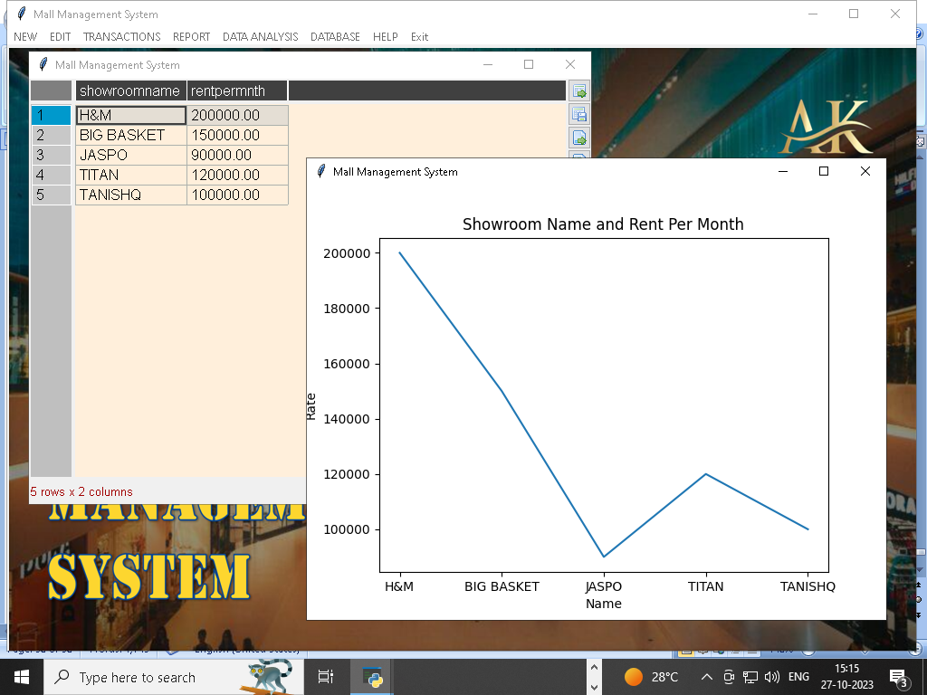

CSV FILE CONVERTER

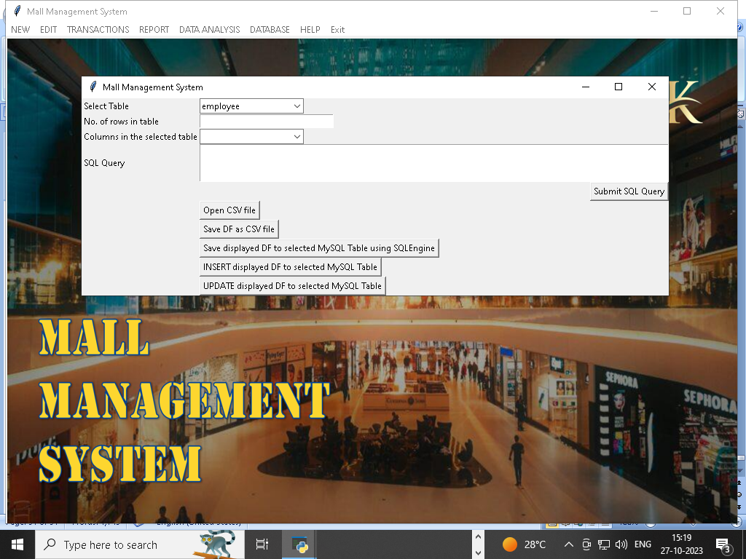

ABOUT, HELP & GUIDE(WINDOWS)

